**CE Web Site Content Update Tool**

1. Download FileZilla from this site: <https://filezilla-project.org/> . This tool the most popular FTP tool out there. It is free and works great. Many web hosting site supports it.

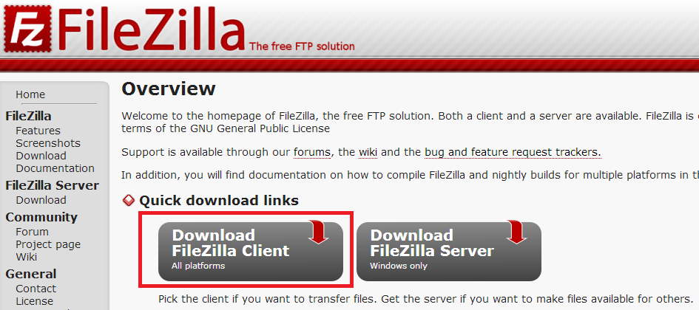

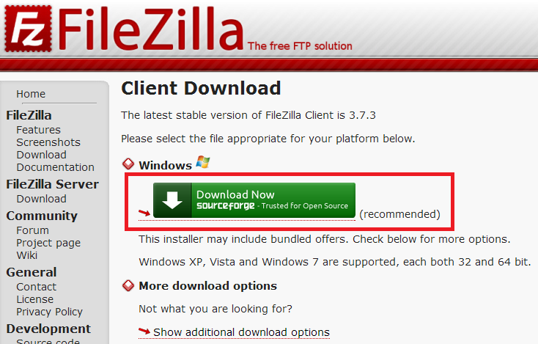

1. Once downloaded, run the FillZilla FTP tool. This tool allows drag-and-drop operation for one or more files and folders. So it is very handy. Currently I have setup only one account as shown below. I will add more accounts in the next few days for content authors.

**Using FileZilla Tool**

1 = snare.arvixe.com

2 = SandyTeng or YvetteLee or KathyChen or TRFu or RobertTung or AnthonyChen

3 = Bellevue2014

4 = click the button

5 = expand to see the site folders

6 = your connection info is saved so that you can click the down arrow to connect next time around

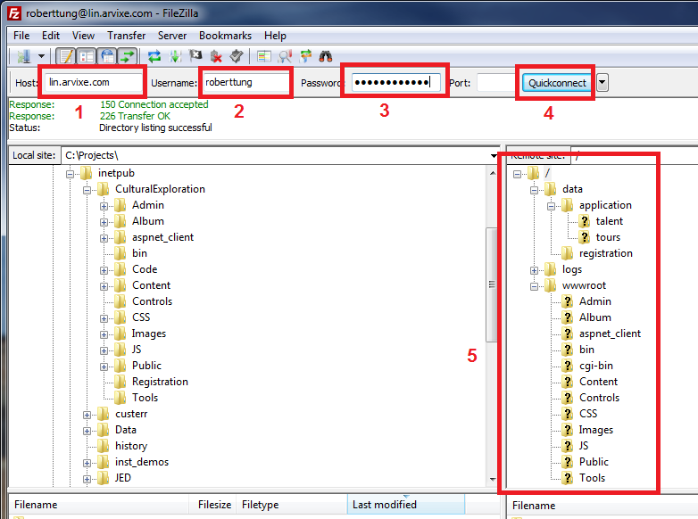

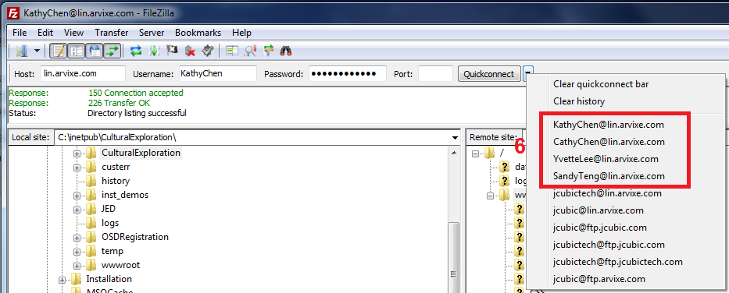

If you encounter problem that you can’t expand the site root folder or see the site file listing, try to change Transfer Mode from *Passive* to *Active* by doing the following:

